Over The Wire

## Level 7 to Level 8

**Step 1: SSH Login**

**Password:** morbNTDkSW6jIlUc0ymOdMaLnOlFVAaj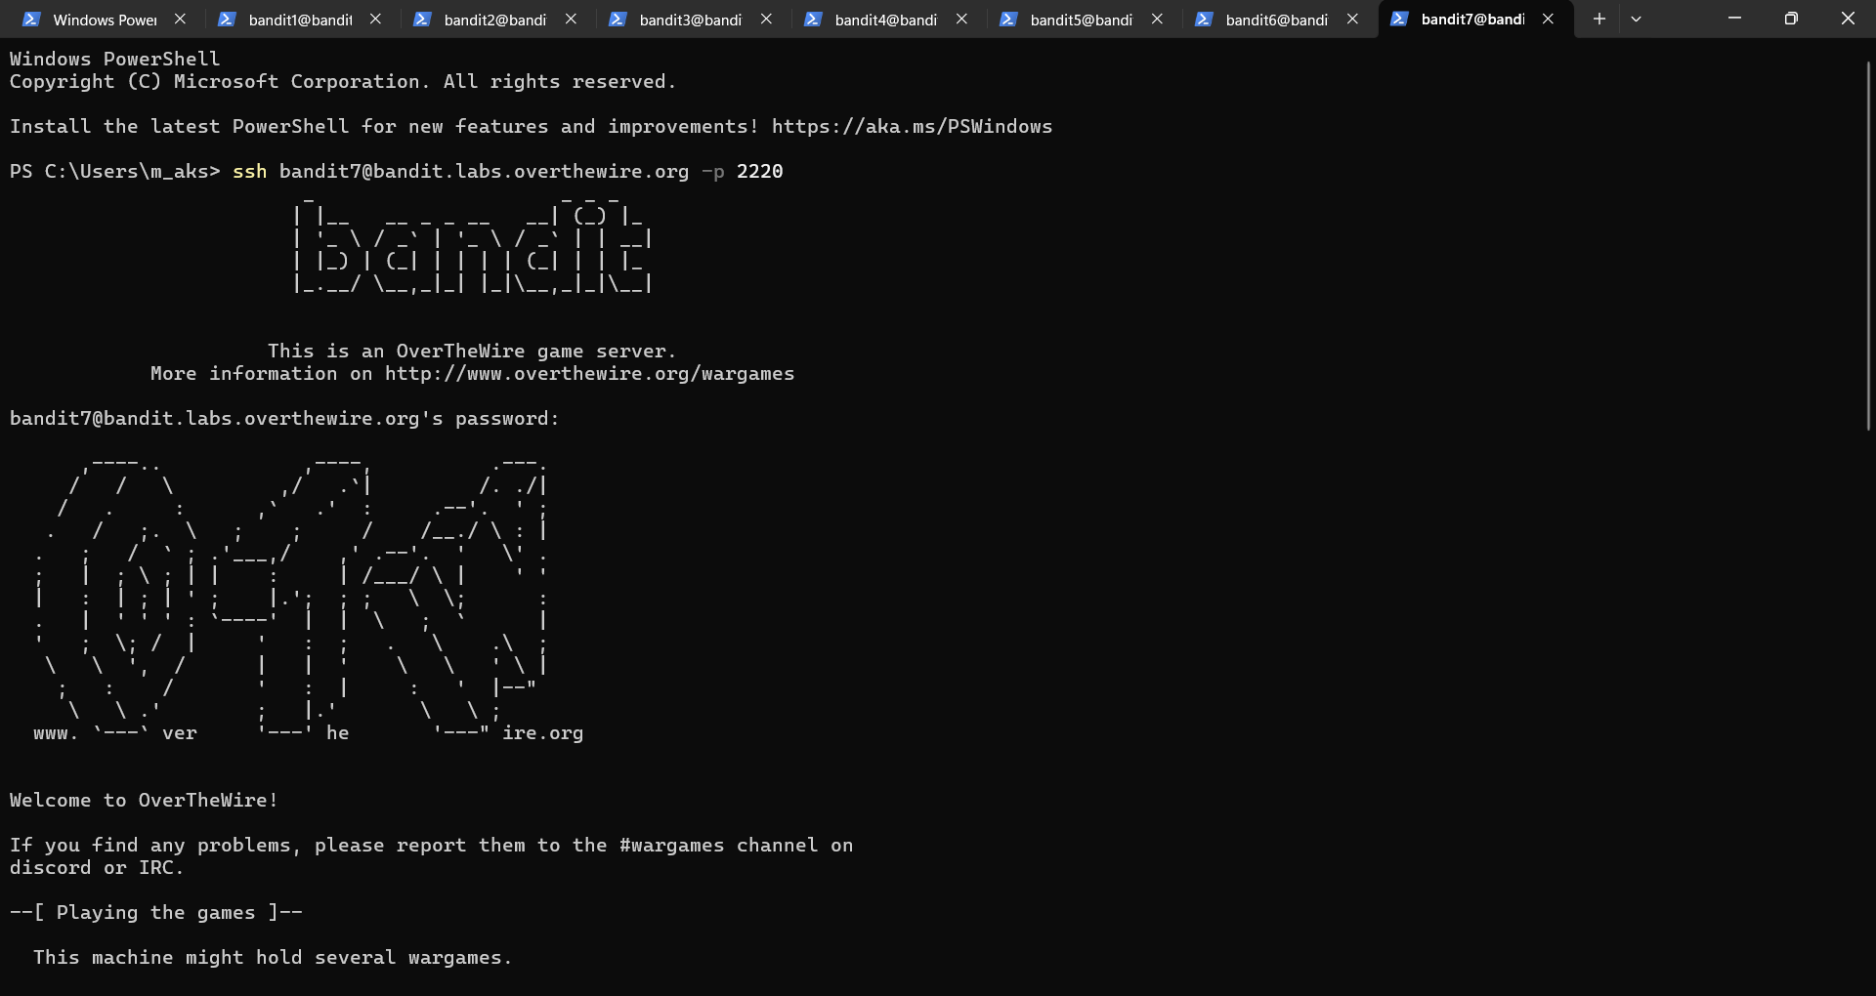

**Step 2: Find Hidden files**

**ls -alps**

**cat data.txt**

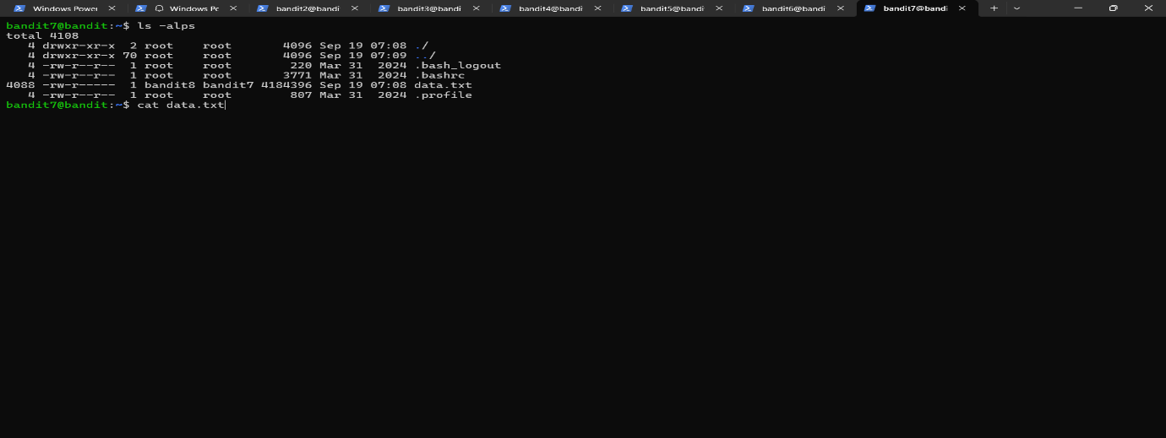

**Step 3: Find the password**

**Strings data.txt | grep "millionth"**

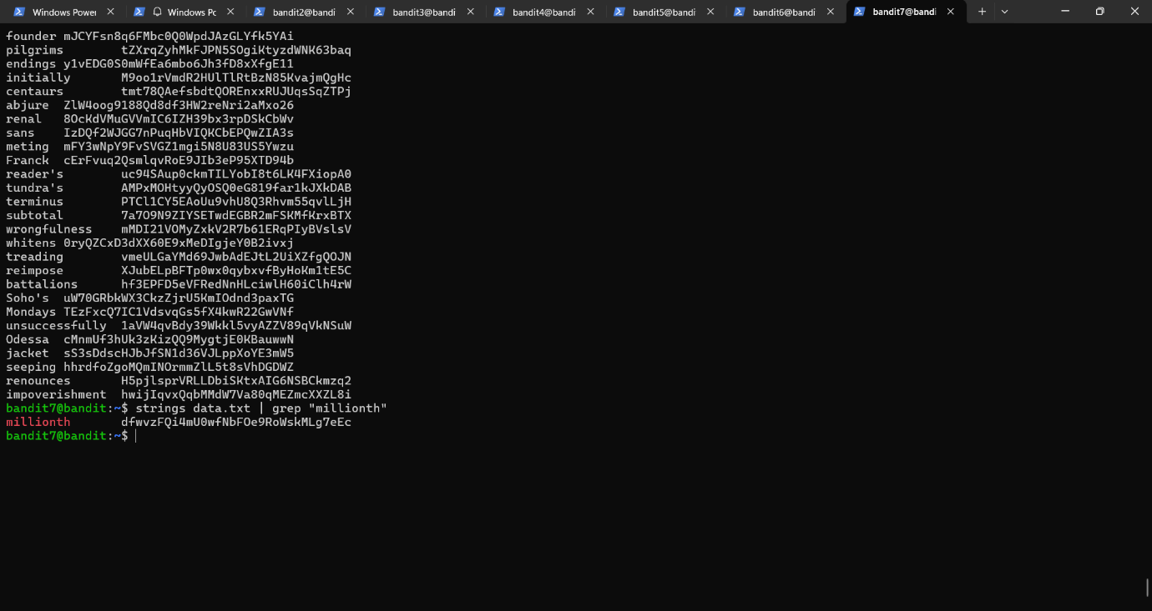

**Password:** **dfwvzFQi4mU0wfNbFOe9RoWskMLg7eEc**